[](http://www.calstatela.edu/centers/hipic)

**CIS5560 Term Project Tutorial**

#### Authors: Ankita Paul, Shuvadeep Kundu

#### Instructor: [Jongwook Woo](https://www.linkedin.com/in/jongwook-woo-7081a85)

#### Date: 05/17/2019

#### Lab Tutorial

#### Ankita Paul ([apaul11@calstatela.edu](mailto:apaul11@calstatela.edu))

#### Shuvadeep Kundu ([skundu@calstatela.edu](mailto:skundu@calstatela.edu))

#### 05/17/2019

#### Iowa Liquor Sales Predictive Analysis applying Machine Learning Algorithms

**Objectives**

In this hands-on lab, you will learn how to implement the following machine learning algorithms in Microsoft Azure ML Studio to build models for predicting liquor sales of the state of Iowa:

* Linear Regression
* Boosted Decision Tree Regression
* Decision Forest Regression

**Platform Specifications**

* Microsoft Azure Machine Learning Studio
* Number of Nodes : Single node
* Total Memory Size : 10 GB
* Maximum number of modules : 100

**Steps in building the experiments**

1. Data Preparation
2. Splitting the data
3. Training the model
4. Evaluation

**Creating a Sample dataset from the original big dataset**

1. Open a browser and browse to [https://studio.azureml.net.](https://studio.azureml.net/) Then sign in using the Microsoft account associated with your Azure ML account.
2. In the Azure ML Studio, go to the **Experiments** page, click **New** at the bottom of the page. Then in the collection of Microsoft samples, select **Blank Experiment**. This creates a blank experiment. Give it the title **Sampling**.
3. With the **Sampling** experiment open, at the bottom left, click **NEW**. Then in the **NEW** dialog box, click the **DATASET** tab.
4. Go to **FROM LOCAL FILE**, choose file **iowa_Liquor_Sales.csv** and click **Ok** to upload a new dataset.

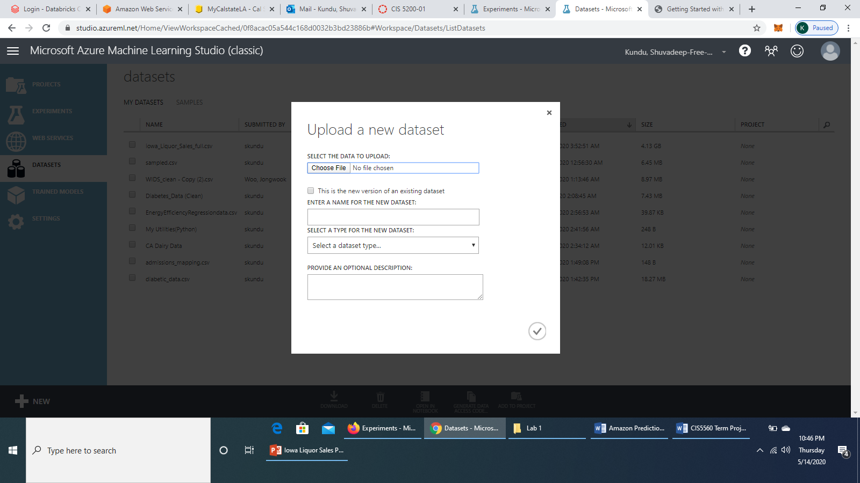

4. Once the dataset is uploaded, in the **Sampling** experiment items pane on the left, expand **Saved Datasets**, expand **My Datasets**, and drag **iowa_Liquor_Sales.csv** to the experiment canvas in the middle of the page.

6. Search for **Partition and Sample** module and drag it to the canvas below the dataset module. Connect the output of the **iowa_Liquor_Sales.csv** dataset to the **Dataset** input of the **Partition and Sample** module. In the **Properties** pane of the **Partition and Sample** module, select the fields as following:

**Partition or sample mode :**  Sampling

**Rate of sampling :** 0.01

**Random seed for sampling :** 1234

**Stratified split for sampling :** True

**Launch Column Selector :** Sale (Dollars)

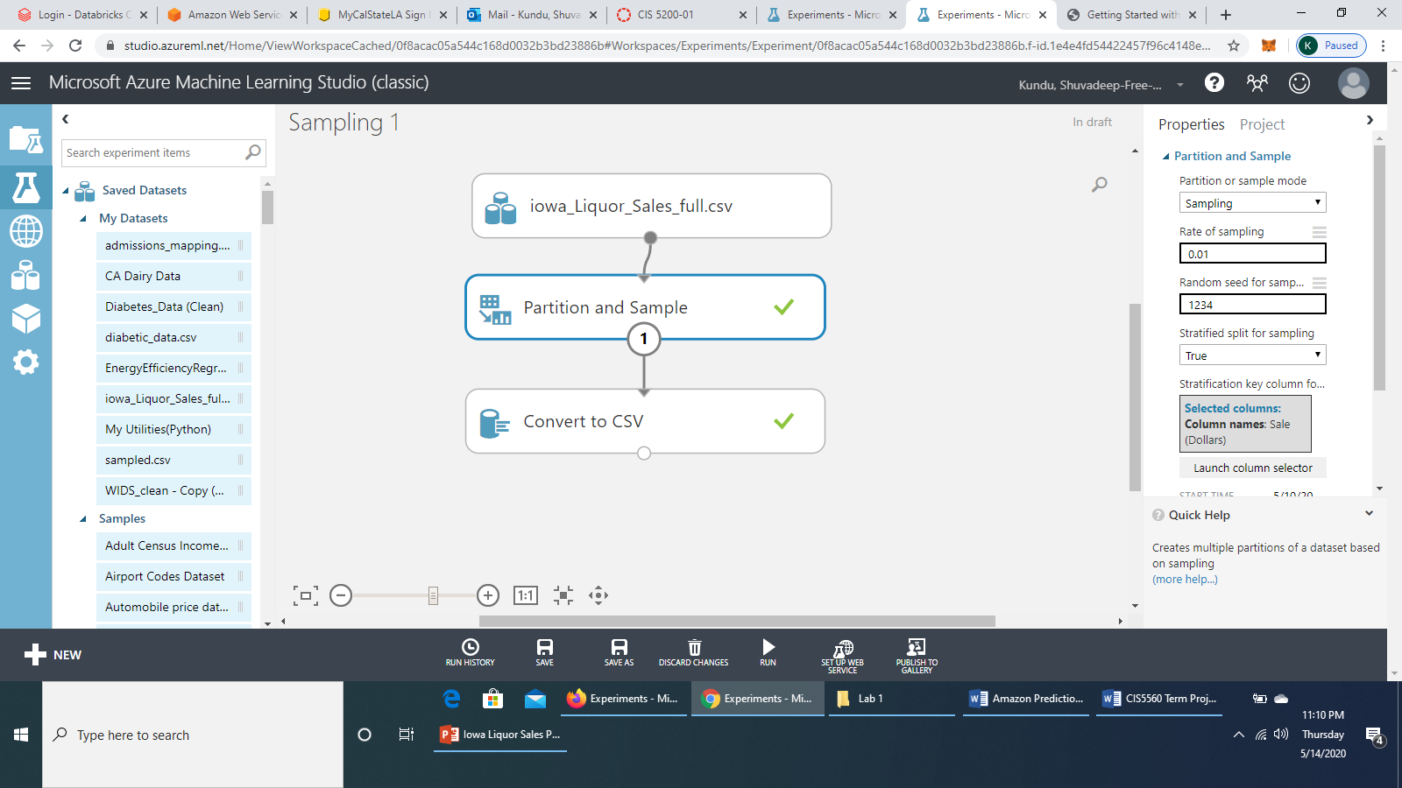

7. Search for **Convert to CSV** module and drag it to the canvas. Connect the output port (**Results Dataset**) of *Partition and Sample* module to the **Dataset** port of **Convert to CSV** module.

The experiment would look like this:

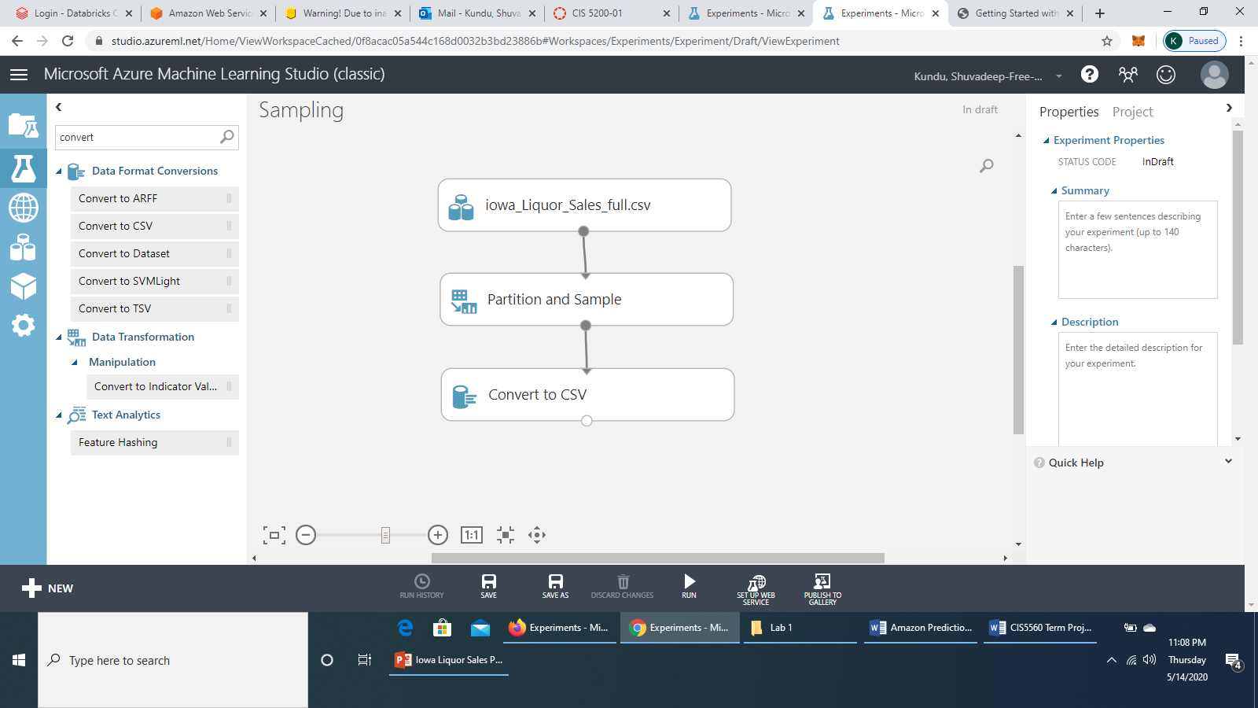

8. **Save** the experiment and **Run** it. Once it has finished running, right click on the **Results dataset** (output) port of the **Convert to CSV** module and **Download** the sampled dataset. Name it as **sample.csv** and save it. Upload this new dataset **sample.csv** to the Datasets page of Azure ML Studio in the same way like the *iowa_Liquor_Sales.csv* dataset was uploaded. We would use this **sample.csv** dataset to build our Machine Learning models and run experiment on it.

**Linear Regression**

**i) Data Preparation**

1. Open a browser and browse to [https://studio.azureml.net.](https://studio.azureml.net/) Then sign in using the Microsoft account associated with your Azure ML account.
2. Create a new blank experiment and give it the title **IOWA – Linear Regression – Cross validation + Tune Model Hyperparameters**.
3. In the experiment items pane on the left, expand **Saved Datasets**, expand **My Datasets**, and drag **sample.csv** to the experiment canvas.
4. Search for **Partition and Sample** module and connect the output port of **sample.csv** module to the **Dataset** port of **Partition and Sample** module. In the **Properties** pane of **Partition and Sample** module, set the configurations as follows:

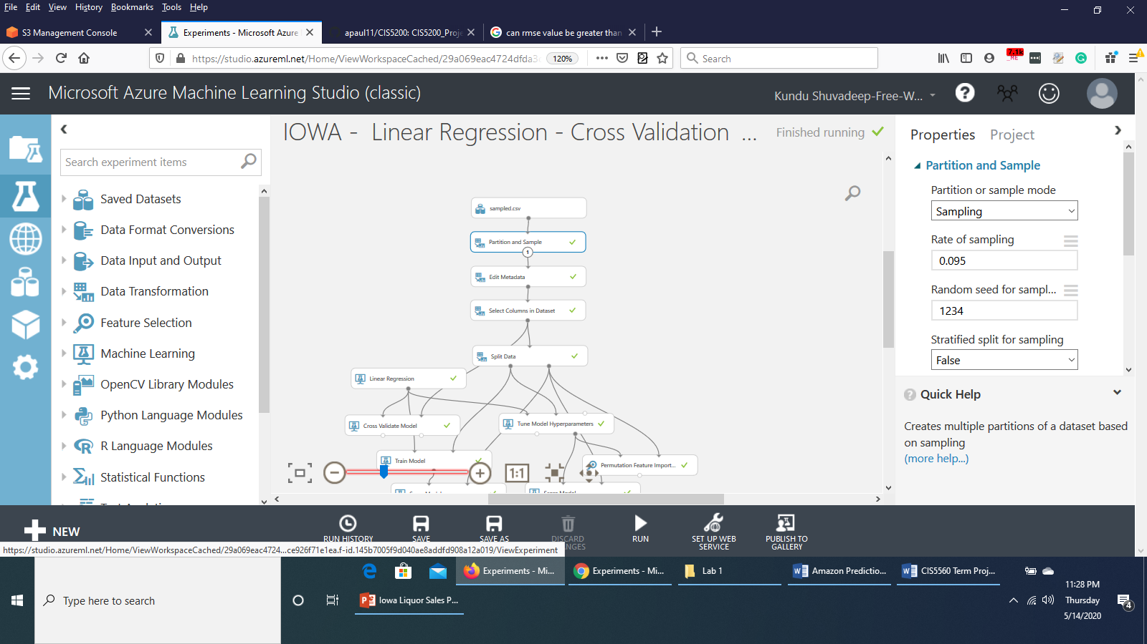

1. Search for **Edit Metadata** module and drag it to the canvas. Connect the **Results Dataset** (output) port of *Partition and Sample* module to the **Dataset** port of *Edit Metadata* module. In the Properties pane of *Edit Metadata* module, **Launch Column Selector.**

**With Rules > Begin With > All Columns**  and select **Include column names.** Select the columns *Store Number, Zip Code, County Number, Category, Item Number* as follows :

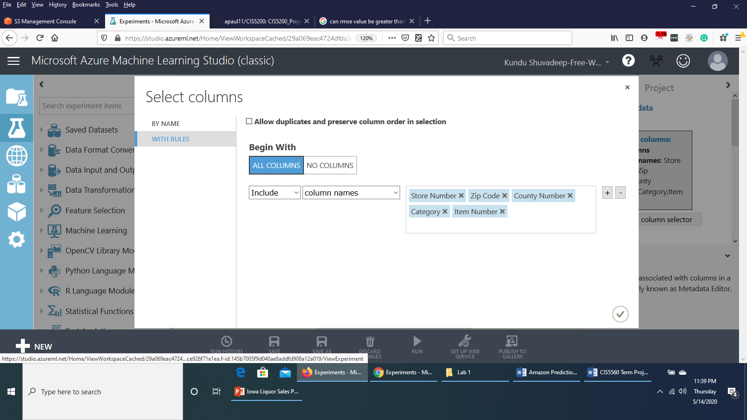

Select **Ok**.

Set the rest of the configurations as follows:

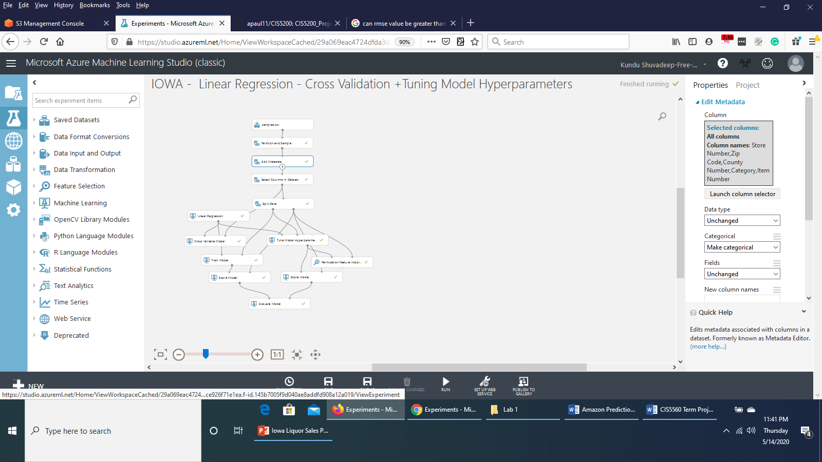

6. Search for **Select Columns in Dataset** module. Connect the **Results Dataset** port of **Edit Metadata** module to the **Dataset** port of **Select Columns in Dataset** module. **Launch column selector** and select **All columns, All features** as shown below:

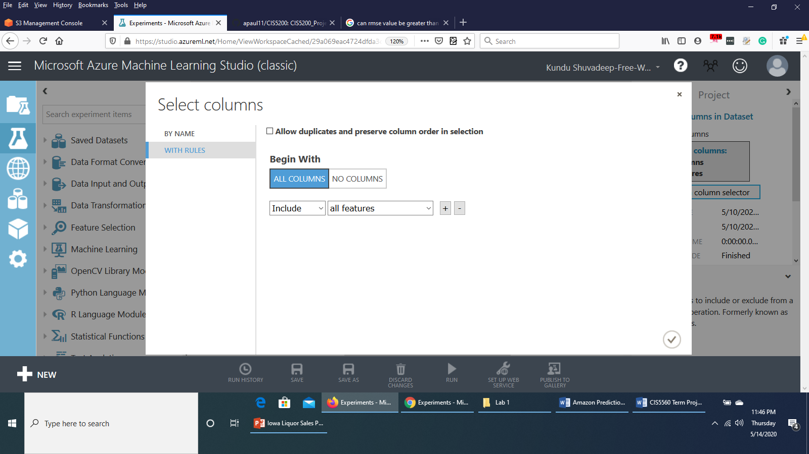

Save the experiment and run it.

The experiment would appear like this till now:

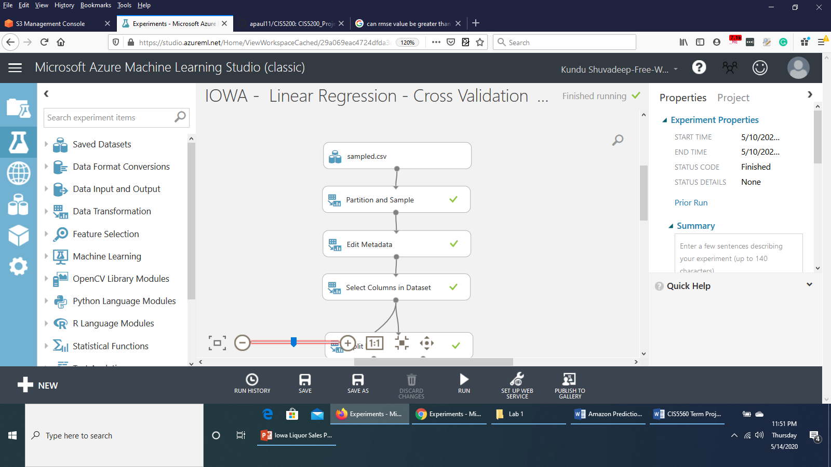

**ii) Splitting the data**

Now that the data is prepared, we would split the data into Training dataset and Testing dataset.

1. Search for the **Split Data** module and drag it onto the Canvas.
2. Connect the **Results dataset** output of the **Select Columns in Dataset** module to the input of the **Split Data** module.
3. On the properties pane of the **Split Data** module, configure the properties as shown below:

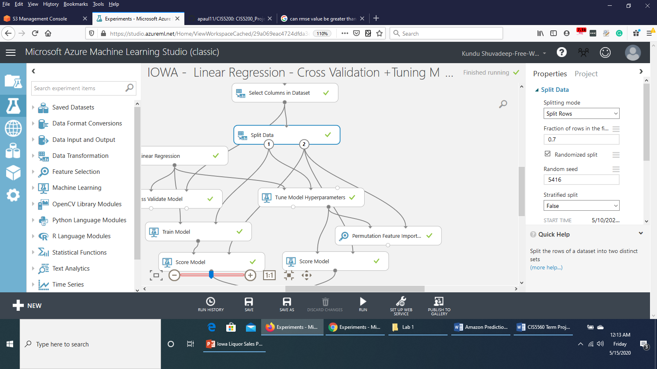

**iii) Training the model**

Now that the data has been split, we can introduce the algorithm and then train the model.

1. Search for **Linear Regression** module and drag it to the canvas. Set the property as shown below:

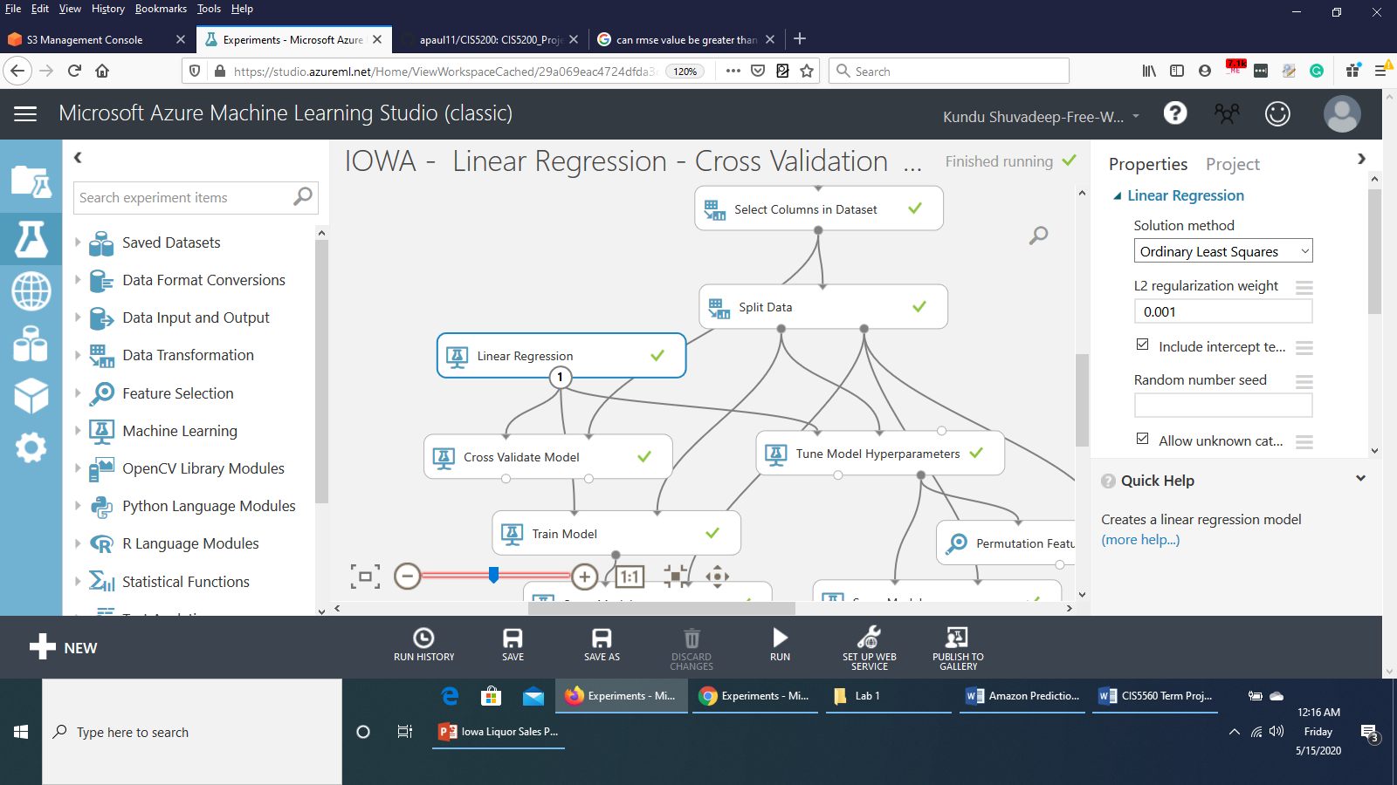

2. Search for the **Cross Validate Model** moduleand drag it onto the canvas under the **Linear Regression** module. Connect the **Untrained model** output port of the **Linear** Regression module to the **Untrained model** input port (Left input port) of the **Cross Validate Model** module**.** Connect the **Results dataset** output of the **Select Columns in Dataset** module to the **Dataset** (right input port) port of the **Cross Validate Model** module. Set the property as shown below:

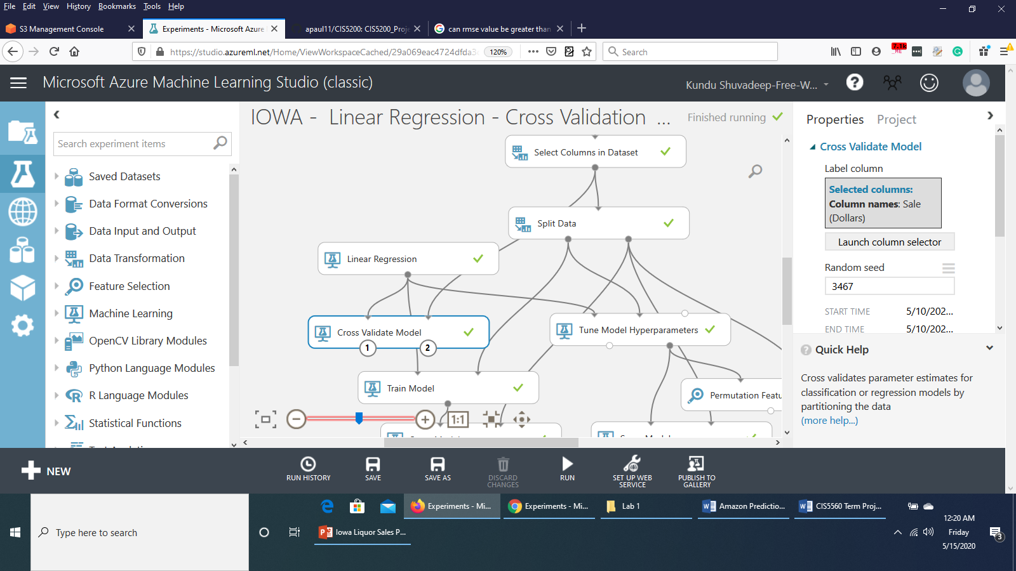

3. Search for the **Train Model** module and drag it onto the canvas under the **Cross Validate Model** module. Connect the **Untrained model** output port of the **Linear Regression** module to the **Untrained model** input port (Left input port) of the **Train Model** module. Connect the **Results dataset1 (left output port) port** of the **Split Model** module to the **Dataset port (right input port)**  of the **Train Model** module. In the properties pane, **Launch column selector** and select the column **Sale (Dollars)** as below:

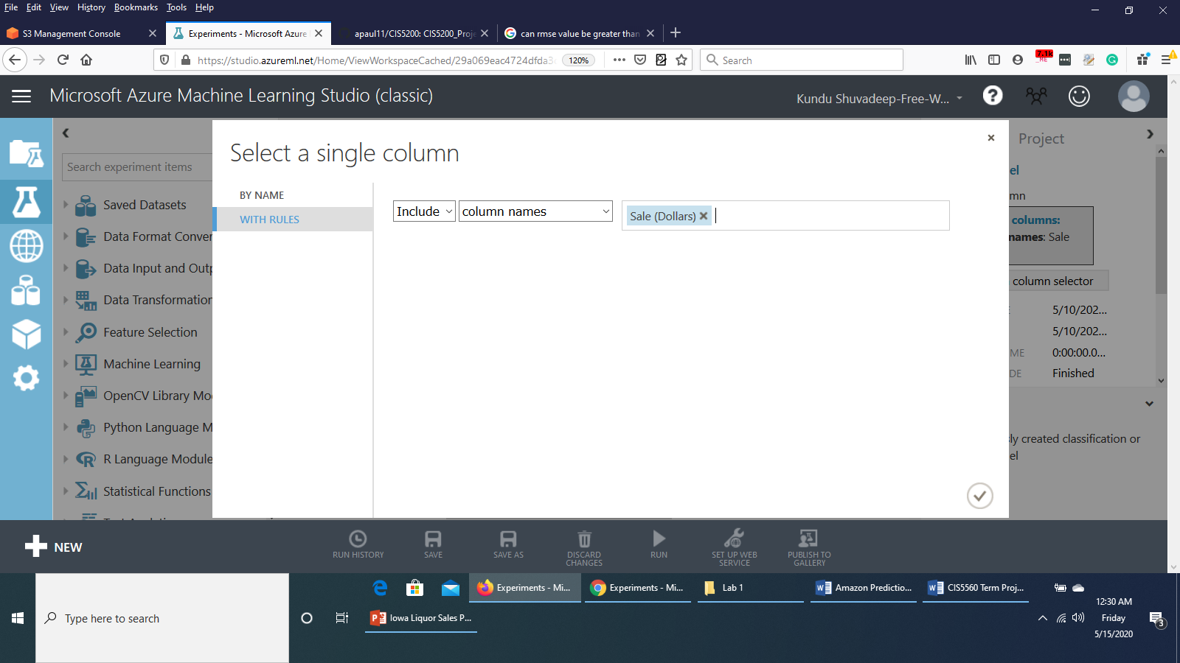

4. Search for the **Tune Model Hyperparameters** module and drag it onto the canvas below the **Split Data** module. Connect the **Untrained model** output port of the **Linear Regression** module to the **Untrained model** input port (**Left input port**) of the **Tune Model Hyperparameters** module. Connect the **Results dataset1 (left output port) port** of the **Split Model** module to the **Training dataset port (middle port)** of the **Tune Model Hyperparameters** module. Set the configurations of the **Tune Model Hyperparameters** module as:

* **Specify parameter sweeping mode :** Random Sweep
* **Maximum number of runs on random sweep :** 5
* **Random seed :** 4567
* **Label column :** Sale (Dollars)
* **Metric for measuring performance of classification :** Accuracy
* **Metric for measuring performance of regression :** Root of mean squared error

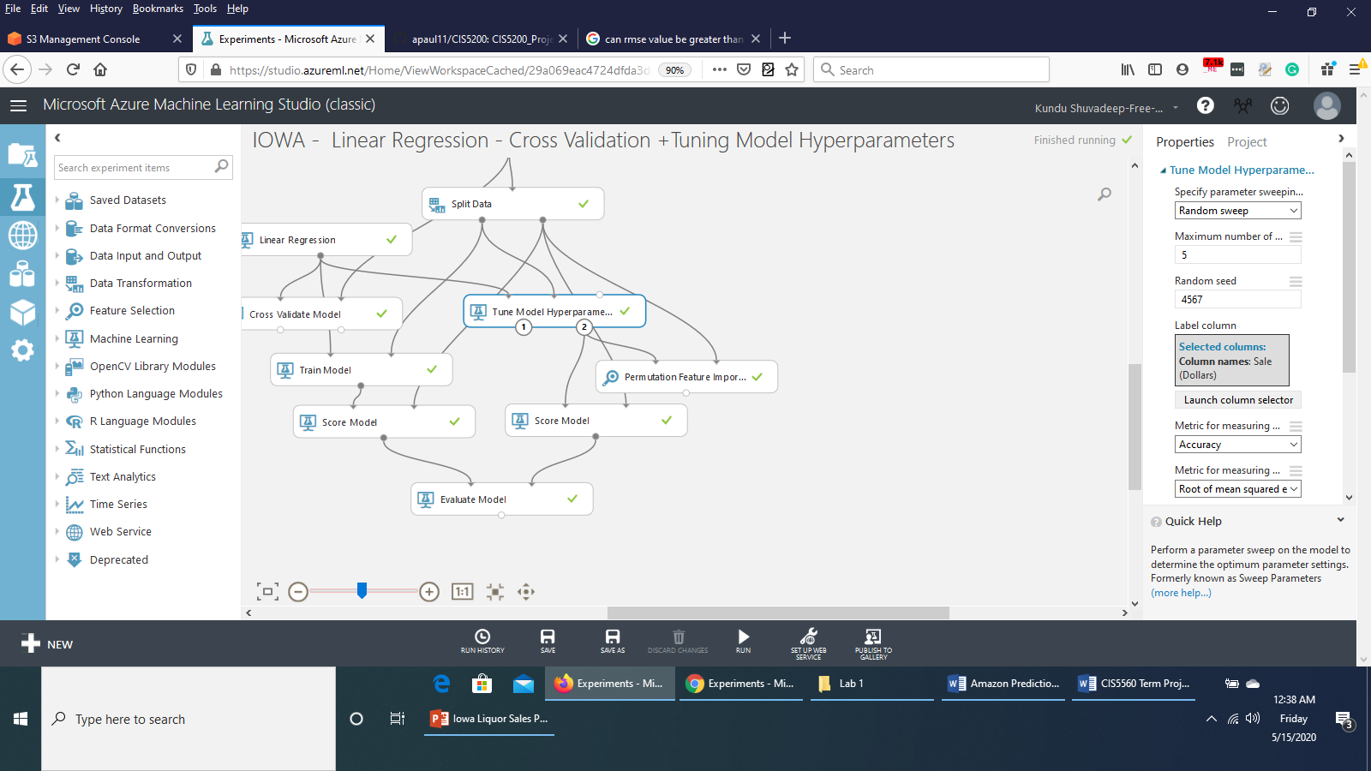

5. Search for the **Permutation Features Importance** moduleand drag it onto the canvas. Connect the **Trained best model port (right output port)** of the **Tune Model Hyperparameters** module to the **Trained model input port (left input port)** of the **Permutation Features Importance** module. Connect the **Results dataset2 port (right output port)** of the **Split Data** module to the **Test data port (right input port)** of the **Permutation Features Importance** module. Set the property of the **Permutation Features Importance** module as shown below:

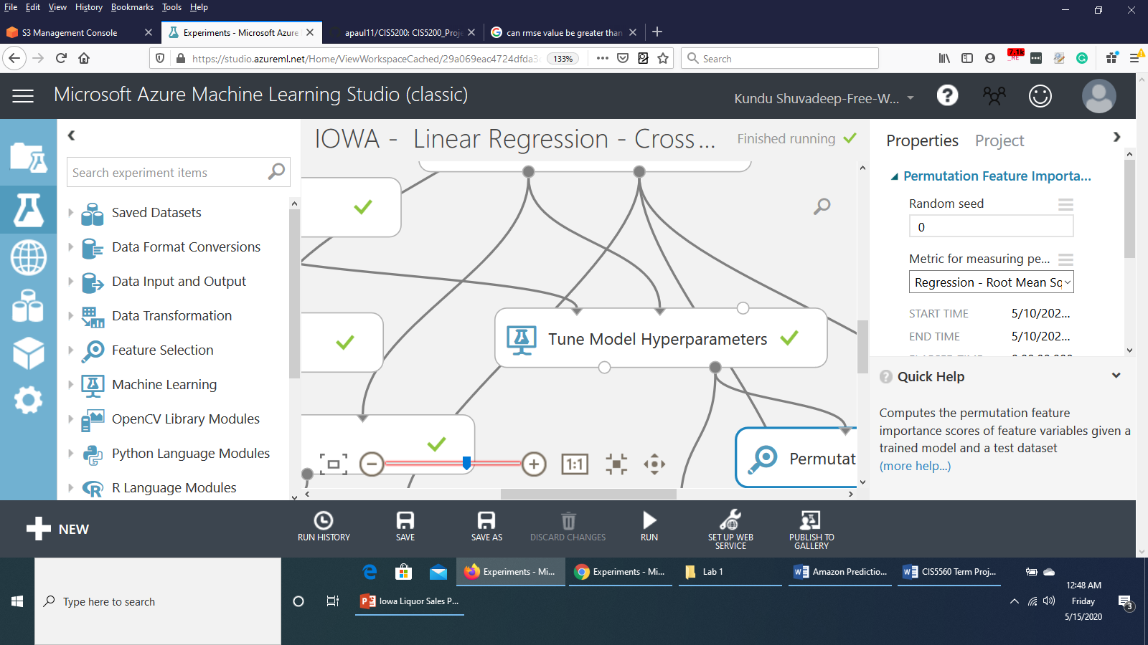

6. Search for **Score Model** module and drag it onto the canvas under the **Train Model** module. Connect the **output port** of the **Train Model** module to the **Trained model input port (left input port)** of the **Score Model** module. Connect the **Results dataset2 port (right output port)** of the **Split Data** module to the **Dataset input port (right input port)** of the **Score Model** module. Set the properties as follows:

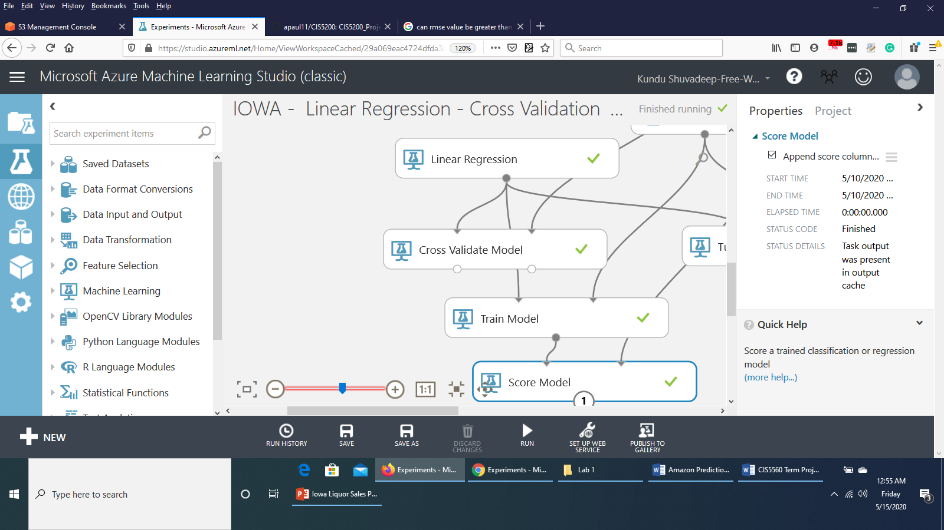

7. Search for **Score Model** module again and drag this second **Score Model** module onto the canvas under the **Tune Model Hyperparameters** module. Connect the **Trained best model port (right output port)** of the **Tune Model Hyperparameters** module to the **Trained model input port (left input port)** of this second **Score Model** module. Connect the **Results dataset2 port (right output port)** of the **Split Data** module to the **Dataset input port (right input port)** of this **Score Model** module. Set the properties same as the first **Score Model** module, i.e,



The experiment would look like this till now:

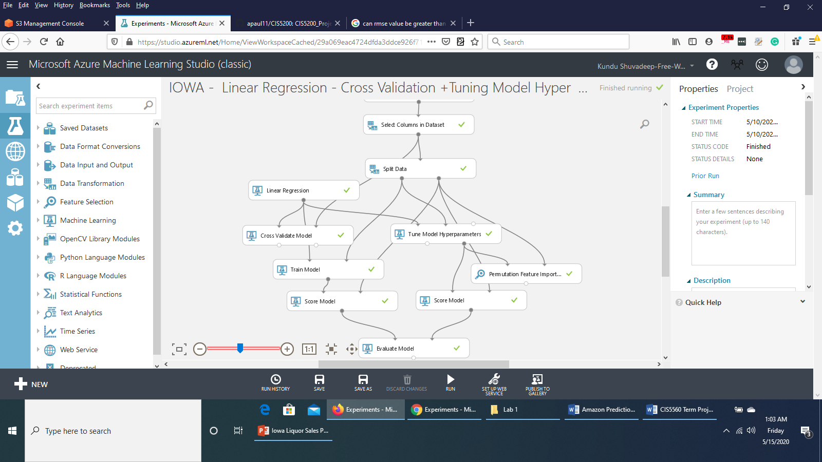

**iv) Evaluating the model**

1. Search for the **Evaluate** module and drag it onto the canvas.
2. Connect the **output port** of the **Score Model** module on the left side to the **left input port** of the **Evaluate** module. Connect the **output port** of the second **Score Model** module to the **right input port** of the **Evaluate** module.

It would appear as below:

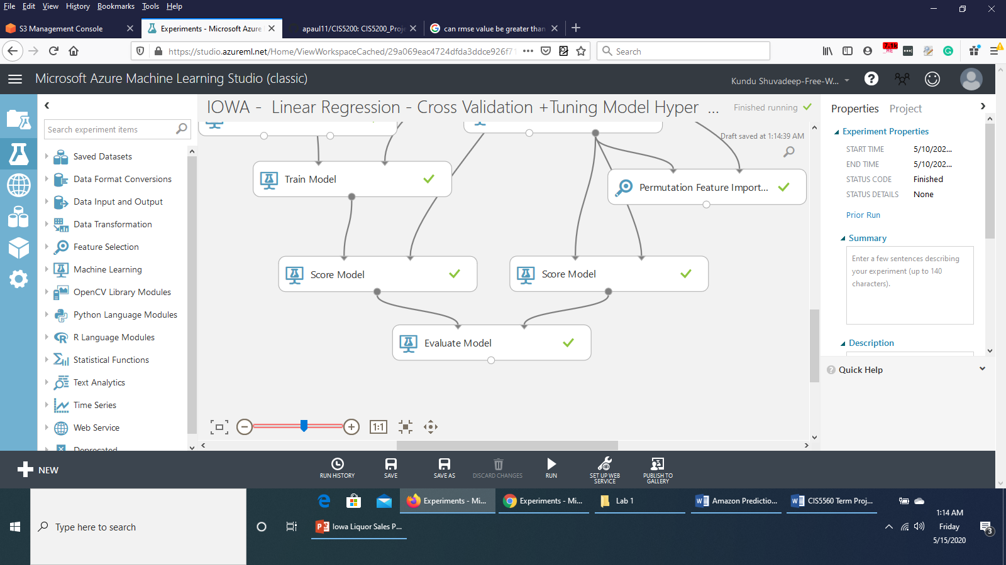

3. Save and run the experiment.

4. When the experiment has finished, **Visualize** the output from the **Evaluate** module. You would see that both the **Cross Validate Model** and **Tune Model Hyperparameters** have performed equally.

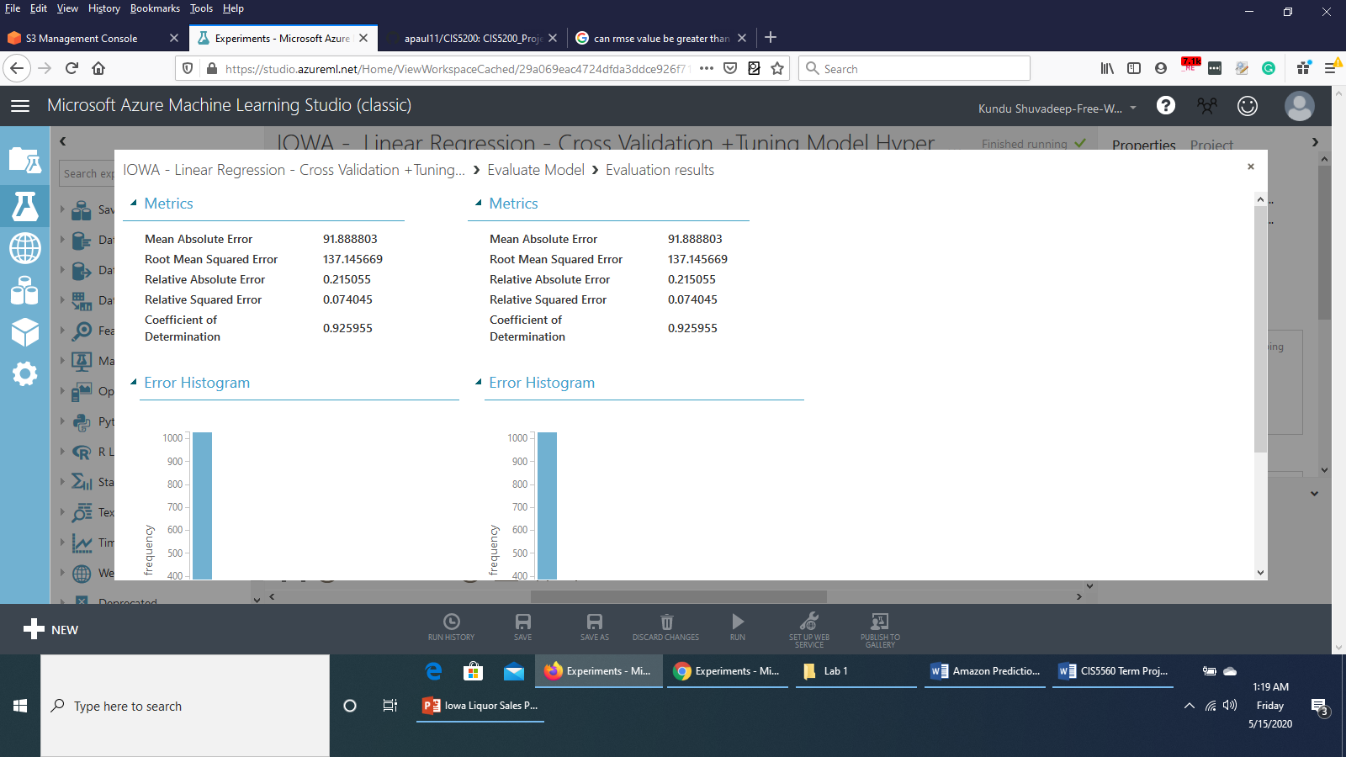

5. You can also visualize the output from the **Permutation Feature Importance** module to see features with their scores of importance and can prune features with less importance. This might improve the model.

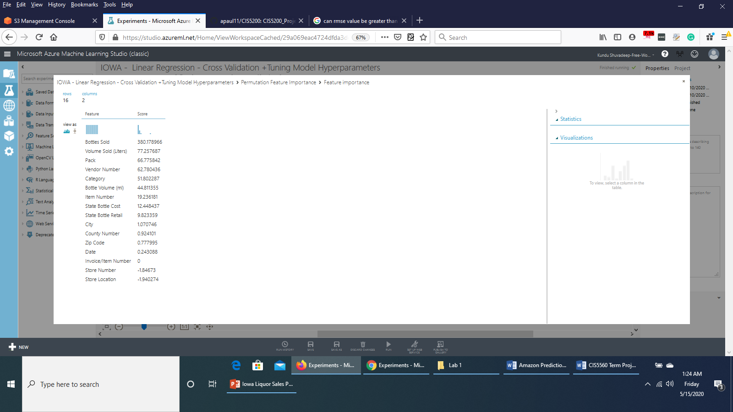

6. Save a copy of this experiment by clicking **Save as** in the bottom of the page and name the experiment copy as **IOWA – Linear Regression – Cross validation + Tune Model Hyperparameters – New.**

7. In the experiment **IOWA – Linear Regression – Cross validation + Tune Model Hyperparameters – New**, on the properties pane of **Select Columns in Dataset** module, **exclude** the columns *Invoice/Item Number, Store Number* and *Store Location* which had 0 and negative scores of feature importance.

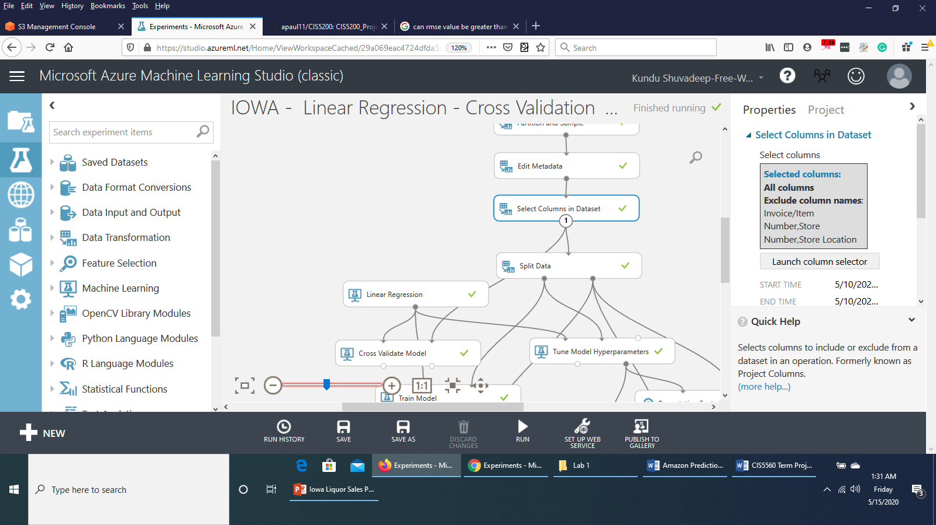

It can be done as follows:

**Launch column selector > WITH RULES > Begin With > ALL COLUMNS > Exclude > column names >** *Invoice/Item Number, Store Number*, *Store Location*

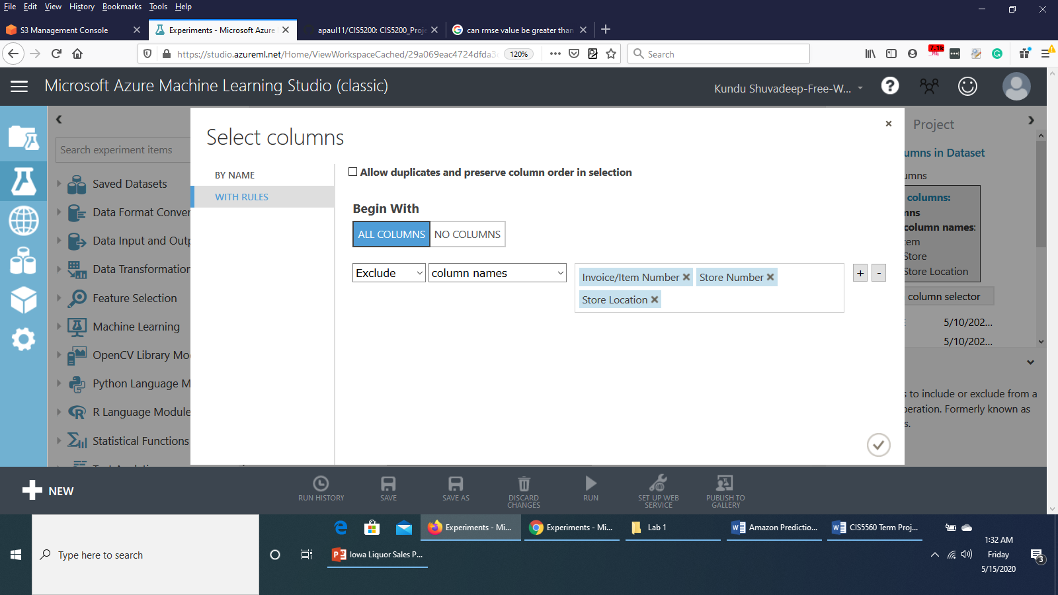

8. Save and run the experiment.

9. When the experiment has finished, **Visualize** the output form the **Evaluate** module to see if any improvement is there. It turned out that the **RMSE** value has actually increased and the **Coefficient of Determination** value decreased.

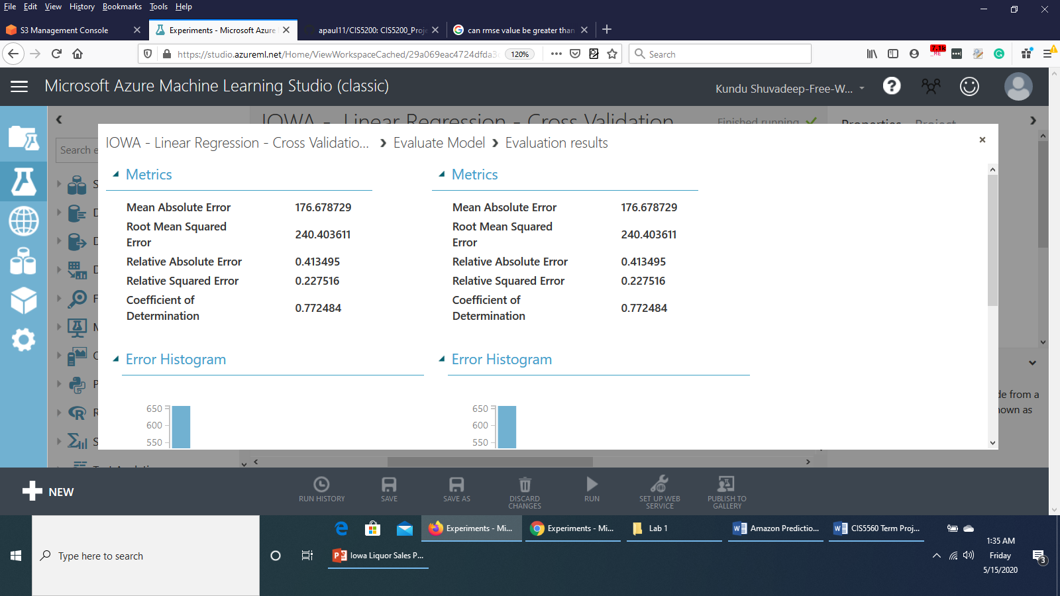

So, the model performed better before pruning the features.

**Boosted Decision Tree Regression**

**i) Data Preparation**

1. Open a browser and browse to [https://studio.azureml.net.](https://studio.azureml.net/) Then sign in using the Microsoft account associated with your Azure ML account.

2. Create a new blank experiment and give it the title **IOWA - Boosted Decision Tree Regression**.

3. In the experiment items pane on the left, expand **Saved Datasets**, expand **My Datasets**, and drag **sample.csv** to the experiment canvas.

4. Search for **Partition and Sample** module and connect the output port of **sample.csv** module to the **Dataset** port of **Partition and Sample** module. In the **Properties** pane of **Partition and Sample** module, set the configurations as follows:



5. Search for **Edit Metadata** module and drag it to the canvas. Connect the **Results Dataset** (output) port of *Partition and Sample* module to the **Dataset** port of *Edit Metadata* module. In the Properties pane of *Edit Metadata* module, **Launch Column Selector.**

**With Rules > Begin With > All Columns**  and select **Include column names.** Select the columns *Store Number, Zip Code, County Number, Category, Item Number* as follows :



Select **Ok**.

Set the rest of the configurations as follows:



6. Search for **Select Columns in Dataset** module. Connect the **Results Dataset** port of *Edit Metadata* module to the **Dataset** port of **Select Columns in Dataset** module. **Launch column selector** and select **All columns, All features** as shown below:



Save the experiment and run it.

The experiment would appear like this till now:



**ii) Splitting the data**

Now that the data is prepared, we would split the data into Training dataset and Testing dataset.

1. Search for the **Split Data** module and drag it onto the Canvas.

2. Connect the **Results dataset** output of the **Select Columns in Dataset** module to the input of the **Split Data** module.

3. On the properties pane of the **Split Data** module, configure the properties as shown below:



**iii) Training the model**

Now that the data has been split, we can introduce the algorithm and then train the model.

1. Search for the **Boosted Decision Tree Regression** module and drag it onto the canvas. Set the property as shown below:

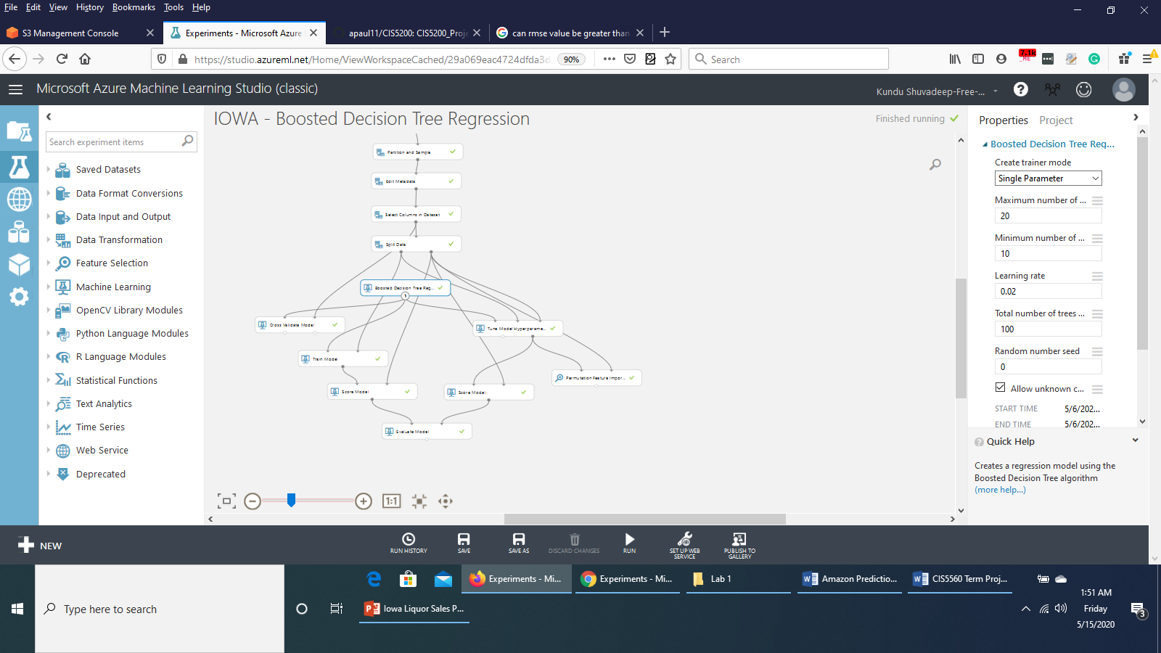

2. Search for the **Cross Validate Model** moduleand drag it onto the canvas under the **Boosted Decision Tree Regression** module. Connect the **Untrained model** output port of the **Boosted Decision Tree Regression** module to the **Untrained model input port (Left input port)** of the **Cross Validate Model** module**.** Connect the **Results dataset** output of the **Select Columns in Dataset** module to the **Dataset (right input port) port** of the **Cross Validate Model** module. Set the property as shown below:



3. Search for the **Train Model** module and drag it onto the canvas under the **Cross Validate Model** module. Connect the **Untrained model** output port of **Boosted Decision Tree Regression** module to the **Untrained model input port (Left input port)** of the **Train Model** module. Connect the **Results dataset1 (left output port) port** of the **Split Model** module to the **Dataset port (right input port)** of the **Train Model** module. In the properties pane, **Launch column selector** and select the column **Sale (Dollars)**.

4. Search for the **Tune Model Hyperparameters** module and drag it onto the canvas below the **Split Data** module. Connect the **Untrained model** output port of the **Boosted Decision Tree Regression** module to the **Untrained model** input port (**Left input port**) of the **Tune Model Hyperparameters** module. Connect the **Results dataset1 (left output port) port** of the **Split Model** module to the **Training dataset port (middle input port)** of the **Tune Model Hyperparameters** module. Connect the **Results dataset2 (right output port) port** of the **Split Model** module to the **Optional validation dataset port (right input port)** of the **Tune Model Hyperparameters** module. Set the configurations of the **Tune Model Hyperparameters** module as below :

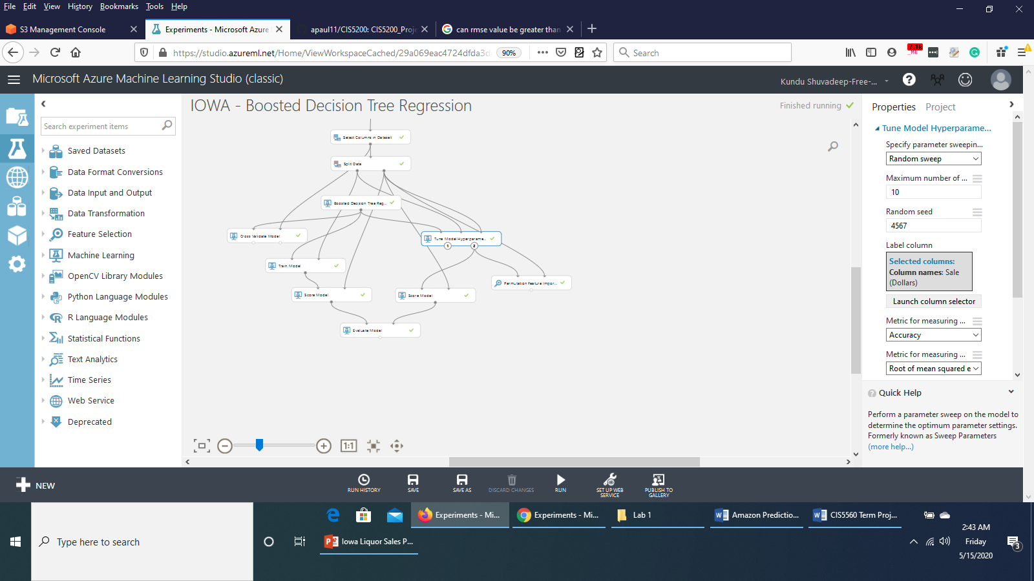

5. Search for the **Permutation Features Importance** moduleand drag it onto the canvas. Connect the **Trained best model port (right output port)** of the **Tune Model Hyperparameters** module to the **Trained model input port (left input port)** of the **Permutation Features Importance** module. Connect the **Results dataset2 port (right output port)** of the **Split Data** module to the **Test data port (right input port)** of the **Permutation Features Importance** module. Set the property of the **Permutation Features Importance** module as shown below:



6. Search for **Score Model** module and drag it onto the canvas under the **Train Model** module. Connect the **output port** of the **Train Model** module to the **Trained model input port (left input port)** of the **Score Model** module. Connect the **Results dataset2 port (right output port)** of the **Split Data** module to the **Dataset input port (right input port)** of the **Score Model** module.

7. Search for **Score Model** module again and drag this second **Score Model** module onto the canvas under the **Tune Model Hyperparameters** module. Connect the **Trained best model port (right output port)** of the **Tune Model Hyperparameters** module to the **Trained model input port (left input port)** of this second **Score Model** module. Connect the **Results dataset2 port (right output port)** of the **Split Data** module to the **Dataset input port (right input port)** of this **Score Model** module.

The experiment figure would look like this till now:

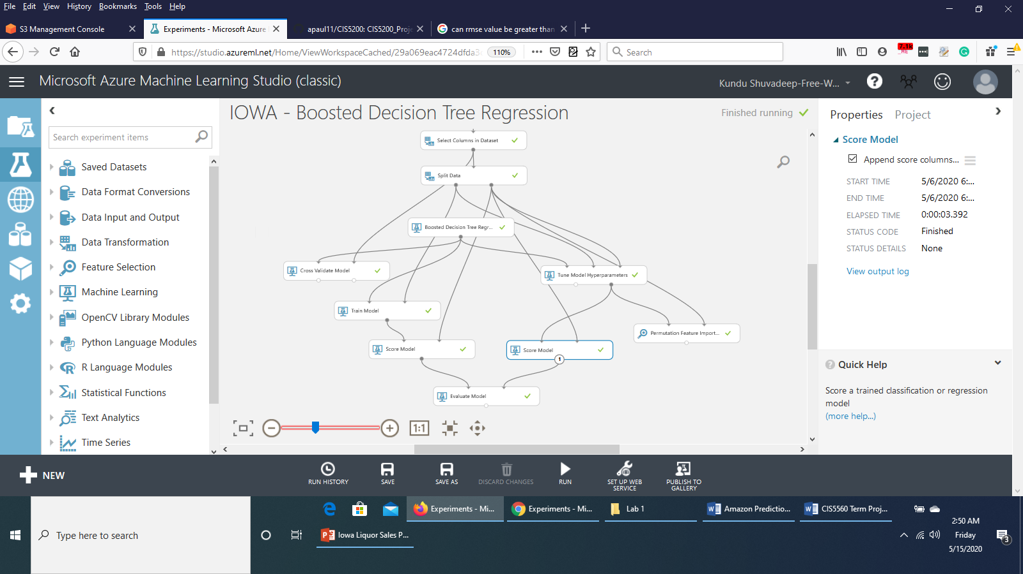

**iv) Evaluating the model**

1. Search for the **Evaluate** module and drag it onto the canvas.
2. Connect the **output port** of the **Score Model** module on the left side to the **left input port** of the **Evaluate** module. Connect the **output port** of the second **Score Model** module to the **right input port** of the **Evaluate** module.

It would appear as below:



3. Save and run the experiment.

4. When the experiment has finished, **Visualize** the output from the **Evaluate** module. We would see that the **Tune Model Hyperparameter** has performed better, with lower **RMSE** value and higher **Coefficient of Determination** value.

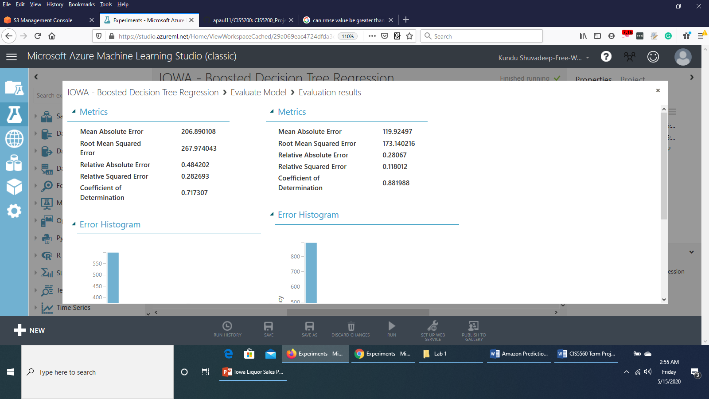

5. You can also visualize the output from the **Permutation Feature Importance** module to see features with their scores of importance and can prune features with less importance. This might improve the model.

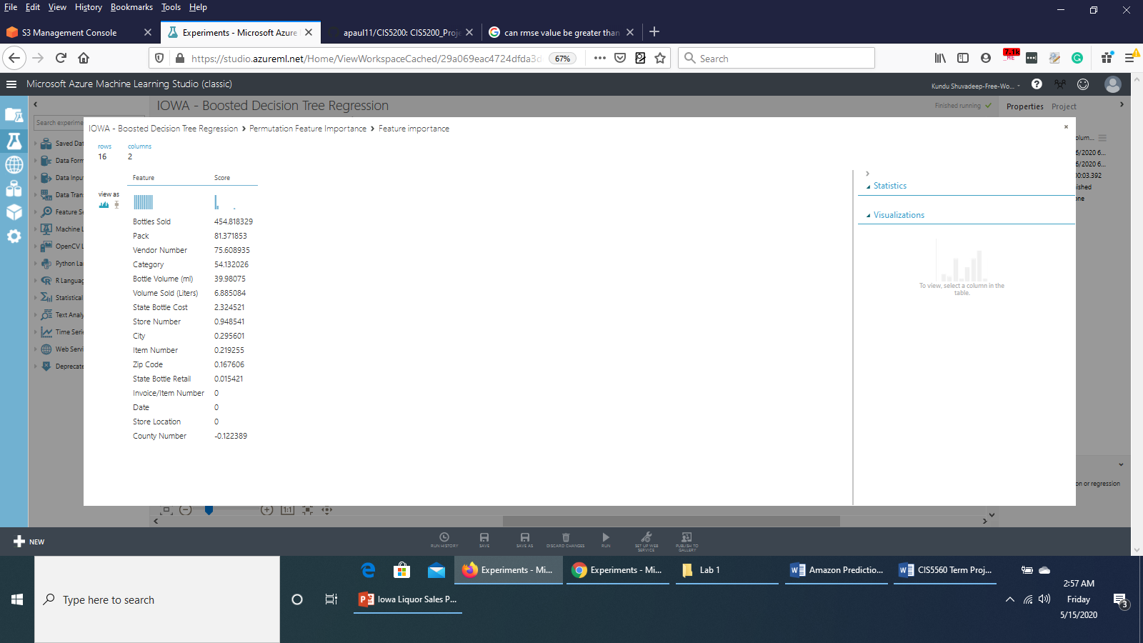

6. Save a copy of this experiment by clicking **Save as** in the bottom of the page and name the experiment copy as **IOWA - Boosted Decision Tree Regression – New.**

7. In the experiment **IOWA - Boosted Decision Tree Regression – New**, on the properties pane of **Select Columns in Dataset** module, **exclude** the columns *Invoice/Item Number, Date, Store Location, County Number, Zip Code*.

It can be done as follows:

**Launch column selector > WITH RULES > Begin With > ALL COLUMNS > Exclude > column names >** *Invoice/Item Number, Date, Store Location, County Number, Zip Code*

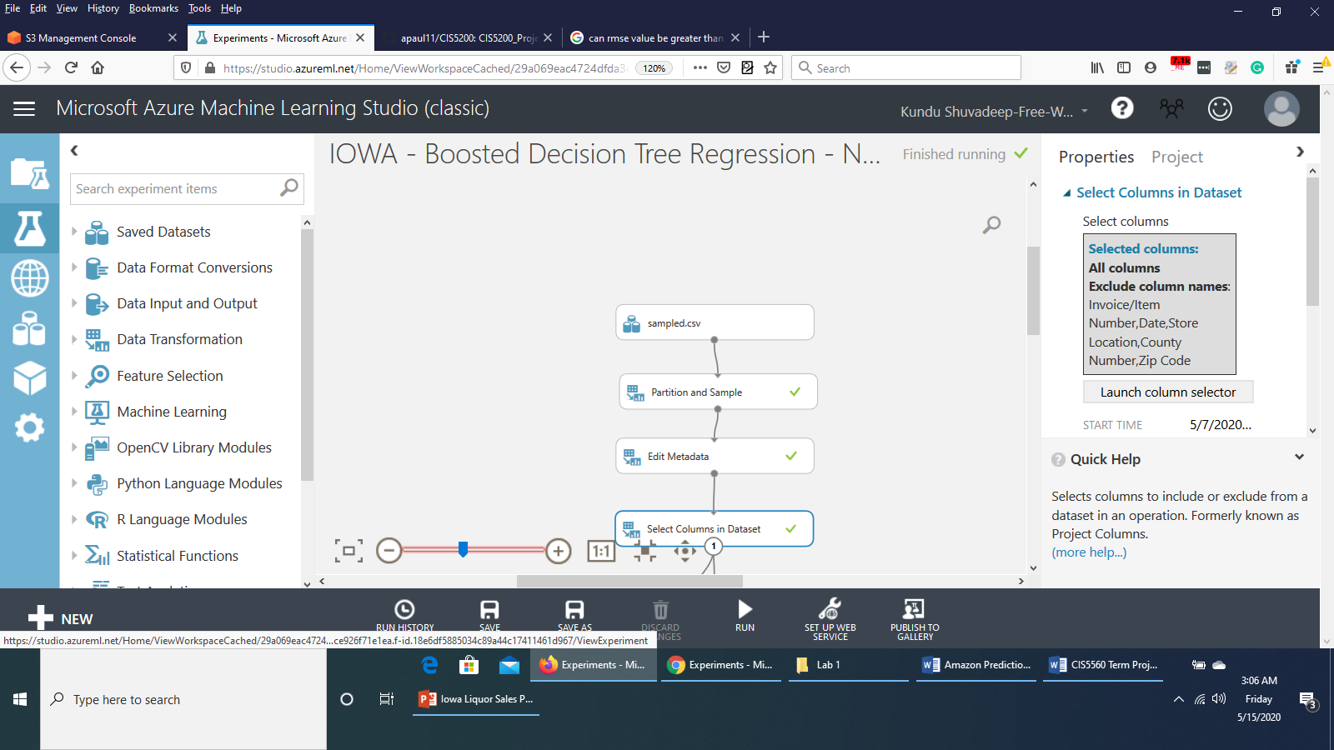

8. . Save and run the experiment.

9. When the experiment has finished, **Visualize** the output form the **Evaluate** module to see if any improvement is there. It turned out that the **RMSE** value has decreased by very negligible amount and the **Coeffiecient of Determination** has increased by very negligible amount.

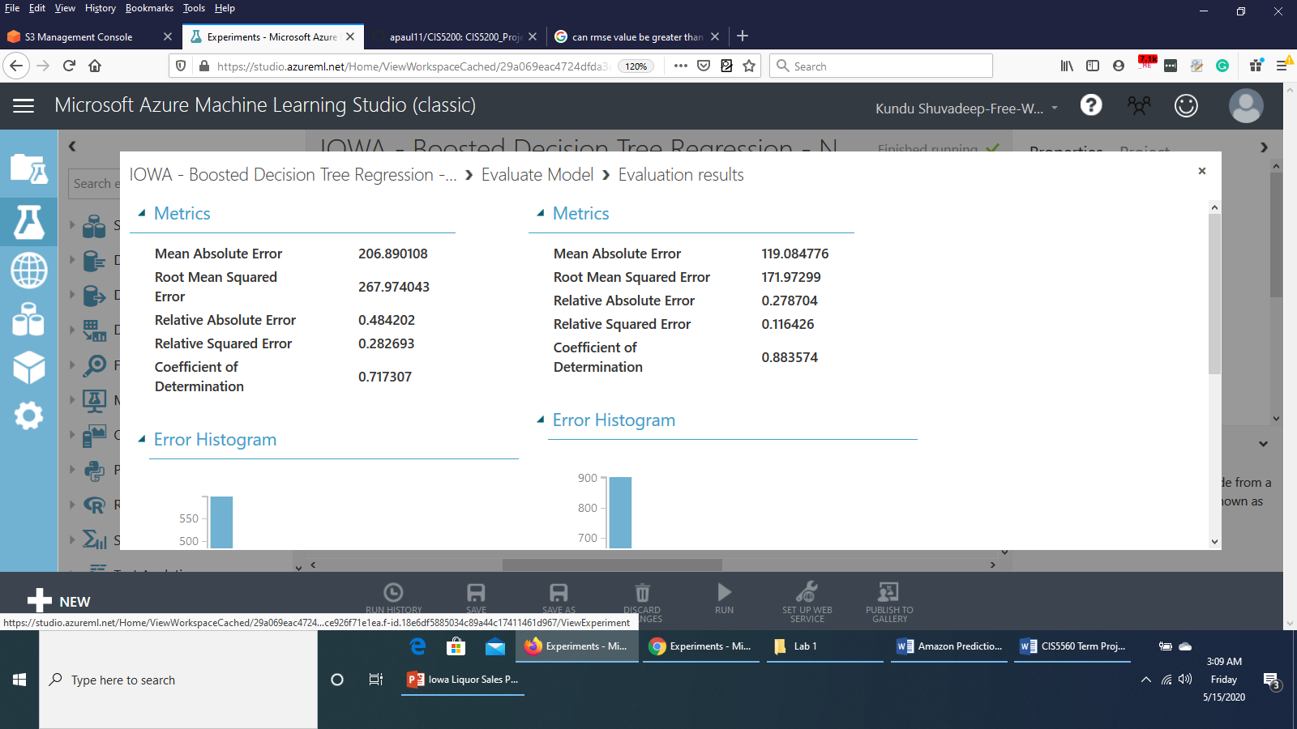

**Decision Forest Regression**

**i) Data Preparation**

1. Open a browser and browse to [https://studio.azureml.net.](https://studio.azureml.net/) Then sign in using the Microsoft account associated with your Azure ML account.

2. Create a new blank experiment and give it the title **IOWA - Decision Forest Regression**.

3. In the experiment items pane on the left, expand **Saved Datasets**, expand **My Datasets**, and drag **sample.csv** to the experiment canvas.

4. Search for **Partition and Sample** module and connect the output port of **sample.csv** module to the **Dataset** port of **Partition and Sample** module. In the **Properties** pane of **Partition and Sample** module, set the configurations as follows:



5. Search for **Edit Metadata** module and drag it to the canvas. Connect the **Results Dataset** (output) port of *Partition and Sample* module to the **Dataset** port of *Edit Metadata* module. In the Properties pane of *Edit Metadata* module, **Launch Column Selector.**

**With Rules > Begin With > All Columns**  and select **Include column names.** Select the columns *Store Number, Zip Code, County Number, Category, Item Number* as follows :



Select **Ok**.

Set the rest of the configurations as follows:



6. Search for **Select Columns in Dataset** module. Connect the **Results Dataset** port of *Edit Metadata* module to the **Dataset** port of **Select Columns in Dataset** module. **Launch column selector** and select **All columns, All features** as shown below:



Save the experiment and run it.

The experiment would appear like this till now:



**ii) Splitting the data**

Now that the data is prepared, we would split the data into Training dataset and Testing dataset.

1. Search for the **Split Data** module and drag it onto the Canvas.

2. Connect the **Results dataset** output of the **Select Columns in Dataset** module to the input of the **Split Data** module.

3. On the properties pane of the **Split Data** module, configure the properties as shown below:



**iii) Training the model**

Now that the data has been split, we can introduce the algorithm and then train the model.

1. Search for the **Decision Forest Regression** module and drag it onto the canvas. Set the property as shown below:

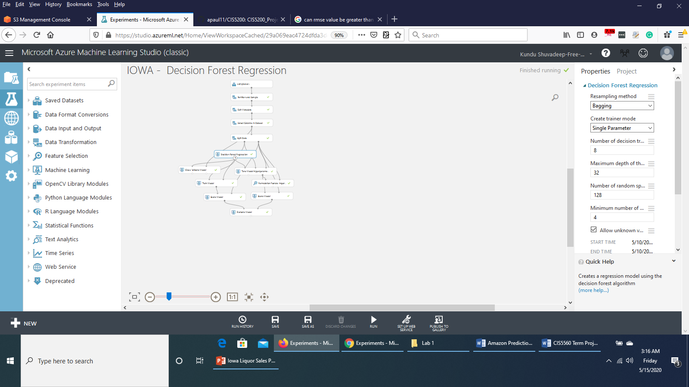

2. Search for the **Cross Validate Model** moduleand drag it onto the canvas under the **Decision Forest Regression** module. Connect the **Untrained model** output port of the **Decision Forest Regression** module to the **Untrained model input port (Left input port)** of the **Cross Validate Model** module**.** Connect the **Results dataset** output of the **Select Columns in Dataset** module to the **Dataset (right input port) port** of the **Cross Validate Model** module. Set the property as shown below:



3. Search for the **Train Model** module and drag it onto the canvas under the **Cross Validate Model** module. Connect the **Untrained model** output port of **Decision Forest Regression** module to the **Untrained model input port (Left input port)** of the **Train Model** module. Connect the **Results dataset1 (left output port) port** of the **Split Model** module to the **Dataset port (right input port)** of the **Train Model** module. In the properties pane, **Launch column selector** and select the column **Sale (Dollars)**.

4. Search for the **Tune Model Hyperparameters** module and drag it onto the canvas below the **Split Data** module. Connect the **Untrained model** output port of the **Decision Forest Regression** module to the **Untrained model** input port (**Left input port**) of the **Tune Model Hyperparameters** module. Connect the **Results dataset1 (left output port) port** of the **Split Model** module to the **Training dataset port (middle input port)** of the **Tune Model Hyperparameters** module. Connect the **Results dataset2 (right output port) port** of the **Split Model** module to the **Optional validation dataset port (right input port)** of the **Tune Model Hyperparameters** module. Set the configurations of the **Tune Model Hyperparameters** module as below :



5. Search for the **Permutation Features Importance** moduleand drag it onto the canvas. Connect the **Trained best model port (right output port)** of the **Tune Model Hyperparameters** module to the **Trained model input port (left input port)** of the **Permutation Features Importance** module. Connect the **Results dataset2 port (right output port)** of the **Split Data** module to the **Test data port (right input port)** of the **Permutation Features Importance** module. Set the property of the **Permutation Features Importance** module as shown below:



6. Search for **Score Model** module and drag it onto the canvas under the **Train Model** module. Connect the **output port** of the **Train Model** module to the **Trained model input port (left input port)** of the **Score Model** module. Connect the **Results dataset2 port (right output port)** of the **Split Data** module to the **Dataset input port (right input port)** of the **Score Model** module.

7. Search for **Score Model** module again and drag this second **Score Model** module onto the canvas under the **Tune Model Hyperparameters** module. Connect the **Trained best model port (right output port)** of the **Tune Model Hyperparameters** module to the **Trained model input port (left input port)** of this second **Score Model** module. Connect the **Results dataset2 port (right output port)** of the **Split Data** module to the **Dataset input port (right input port)** of this **Score Model** module.

The experiment figure would look like this till now:

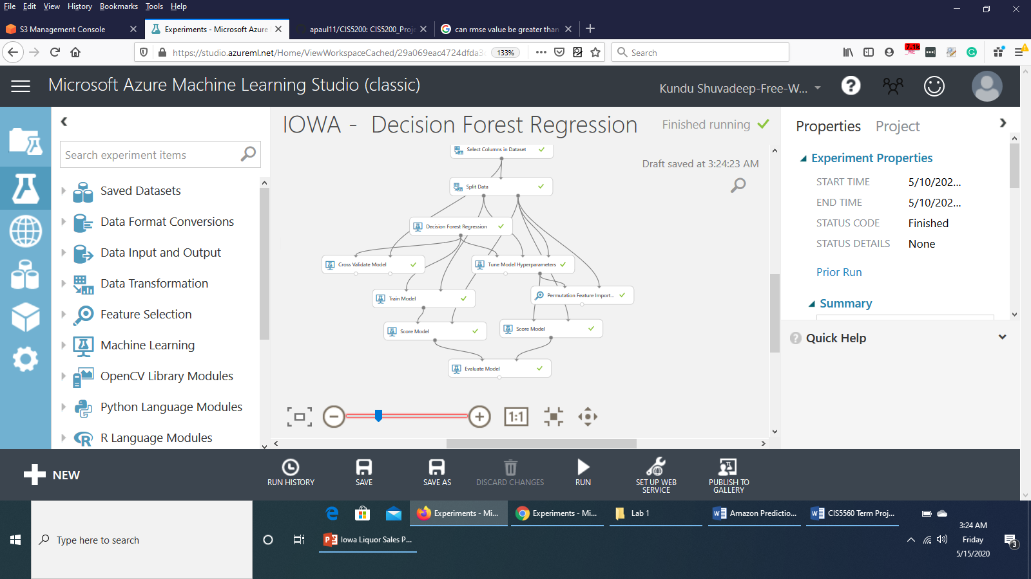

**iv) Evaluating the model**

1. Search for the **Evaluate** module and drag it onto the canvas.
2. Connect the **output port** of the **Score Model** module on the left side to the **left input port** of the **Evaluate** module. Connect the **output port** of the second **Score Model** module to the **right input port** of the **Evaluate** module.

It would appear as below:



3. Save and run the experiment.

4. When the experiment has finished, **Visualize** the output from the **Evaluate** module. We would see that the **Tune Model Hyperparameter** has performed better, with lower **RMSE** value and higher **Coefficient of Determination** value.

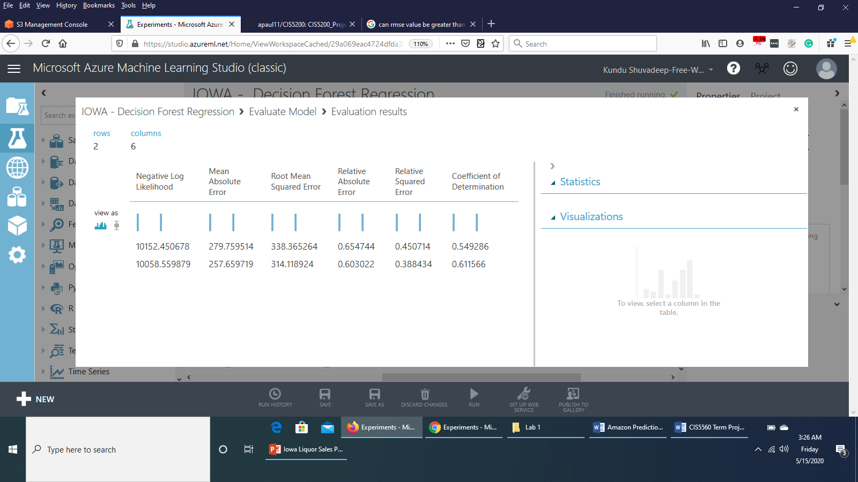

5. You can also visualize the output from the **Permutation Feature Importance** module to see features with their scores of importance and can prune features with less importance. This might improve the model.

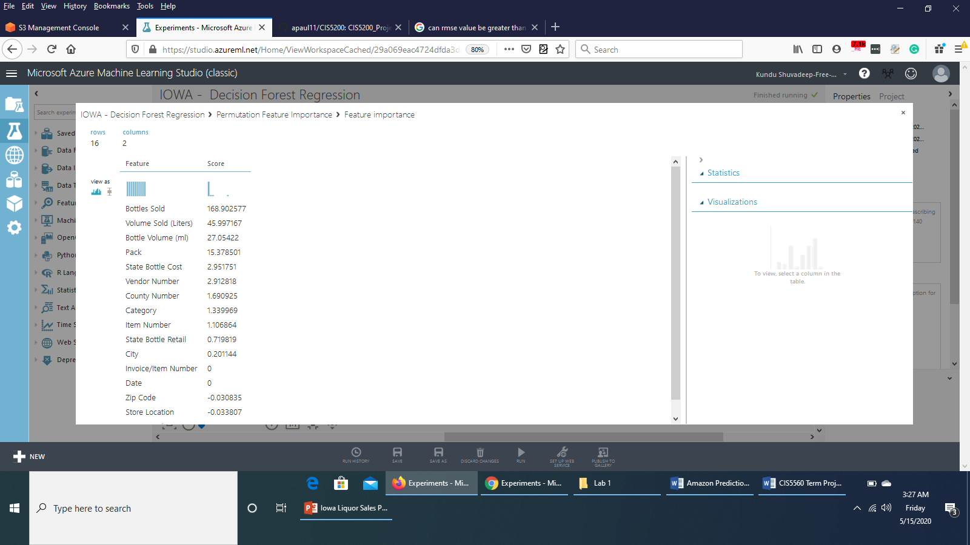

6. Save a copy of this experiment by clicking **Save as** in the bottom of the page and name the experiment copy as **IOWA - Decision Forest Regression - New.**

7. In the experiment **IOWA - Decision Forest Regression - New**, on the properties pane of **Select Columns in Dataset** module, **exclude** the column names *Store Number, Store Location, Zip Code, Date, Invoice/Item Number.*

It can be done as follows:

**Launch column selector > WITH RULES > Begin With > ALL COLUMNS > Exclude > column names >** *Store Number, Store Location, Zip Code, Date, Invoice/Item Number*

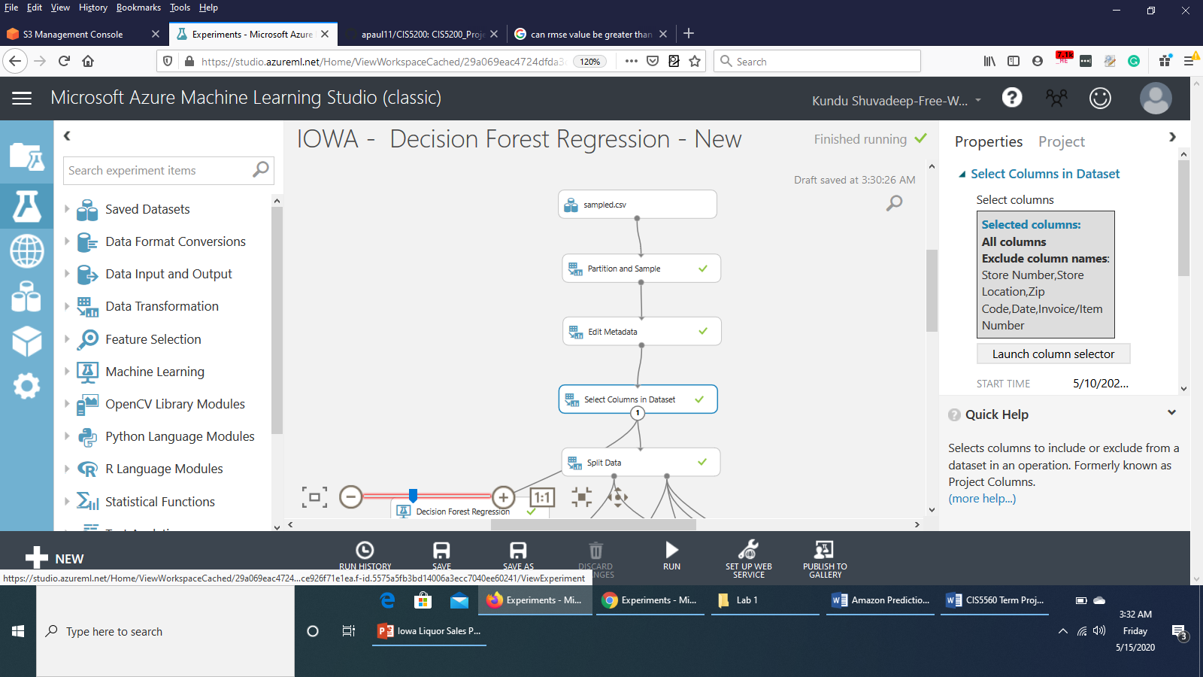

8. . Save and run the experiment.

9. When the experiment has finished, **Visualize** the output form the **Evaluate** module to see if any improvement is there. It turned out that the **RMSE** value has decreased by considerable amount and the **Coeffiecient of Determination** has increased. However, the **Cross Validate Model** performed better this after pruning the features.

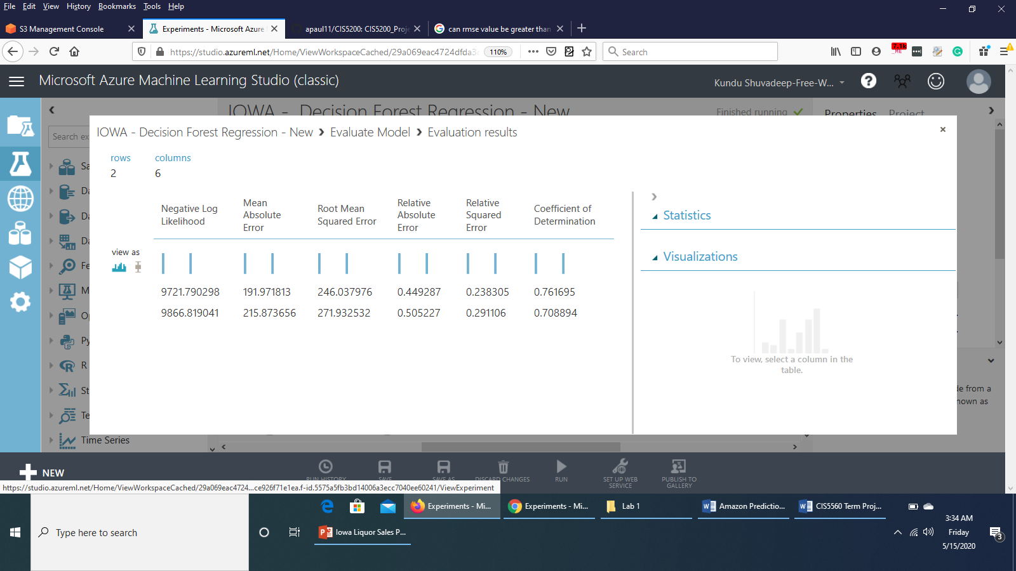

**References:**

1. **URL of Data Source**

* **Original Dataset AWS S3 Link : [4.13 GB]**

<https://projectcis5200.s3-us-west-1.amazonaws.com/iowa_Liquor_Sales.csv>

* **Sampled Dataset AWS S3 Link: [6.45 MB]**

<https://project5560.s3-us-west-1.amazonaws.com/sample.csv>

2. **URL of our Github:** <https://github.com/apaul11/CIS5560>

3. **URL of References** :

* <https://calstatela.instructure.com/files/2788092/download?download_frd=1>
* <https://calstatela.instructure.com/files/2788119/download?download_frd=1>
* <https://turi.com/learn/userguide/supervised-learning/boosted_trees_regression.html>
* Microsoft's DAT203x, Data Science and Machine Learning Essentials